Math 9: Scale Factors and Similarity Final Exam Review
- Enlargements and Reductions
- Drawn an enlargement of the figure using a scale factor of 2.

- Draw a reduction of the figure using a scale factor of 0.5.

- Scale Diagrams
- Determine the missing value.
1 = 13.5
- ?
- Determine the scale factor.
? = 30
? 225
- What scale factor is used to create the image below?
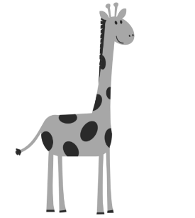The average height of a male giraffe is 6m.

- Similar Triangles
- Are the following triangles similar?
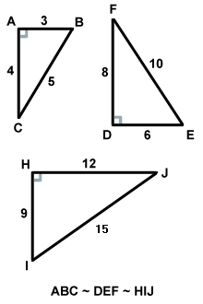
Questions to Review
Page 136 # 6 – 12
143 # 5 – 19
Scale Factors and Similarity Assignment 1
Page 151 # 6 – 11
151 # 12 – 16, 18
157 # 3 – 7, 9, 10, 12, 13, 15
Scale Factors and Similarity Assignment 2
Scale Factors and Similarity Test

- ΔGHI is similar to ΔJKI. What is the missing side?

- A ramp is built as shown below. What is the height of the ramp?

- Similar Polygons
- Decide if the pair of polygons is similar.

- Two regular octagons are shown below. What will the perimeter of the outer octagon be if its side length is 3 times that of the inner?

