Topic 6: Buoyancy
Buoyancy: the tendency for materials to rise or float in a fluid.
Buoyant force: A force that pushes upward on objects submerged in fluids, (gasses/liquids). It is the anti – gravity force. Pushes against gravity. It is measured in Newtons, (N).
***If the buoyant force on an object is equal to or greater than gravitational force/weight the object will float.***
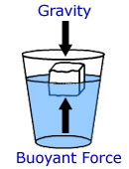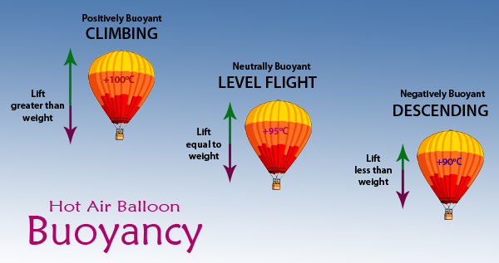
Weight = Gravitational Force
Floating occurs when an object is suspended in/on the fluid.
Average Density: The total mass of all substances divided by total volume. It is useful because it allows objects that would normally sink, (metals), to float. It can also allow floating objects to sink.
*** If average density is lower than the fluids density the object will float. If average density is higher than the fluids density the object will sink.***
Archimedes’ Principle: The buoyant force acting on an object equals the weight/force of gravity of the fluid displaced by the object.
***The volume of water that is displaced by an object submerged in it is equal to the volume of the object.***
Hydrometer: A device used to measure liquid density. (Sinks if liquid has a lower density, rises if liquid has a higher density)
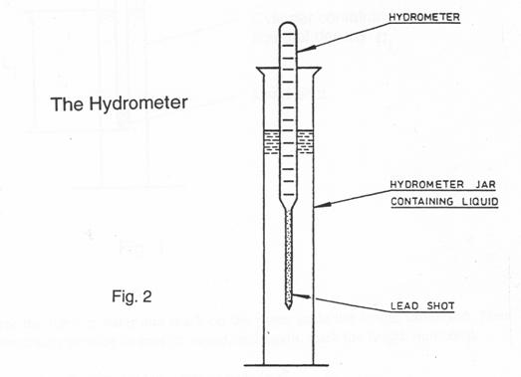

Where you are:
https://www.youtube.com/watch?v=mM1bAtIQkW4
Where you will be:
https://www.youtube.com/watch?v=OhQFdc1mPUA
Read pages 59 – 69, Topic 6 in your textbook

